**Percentile Report**

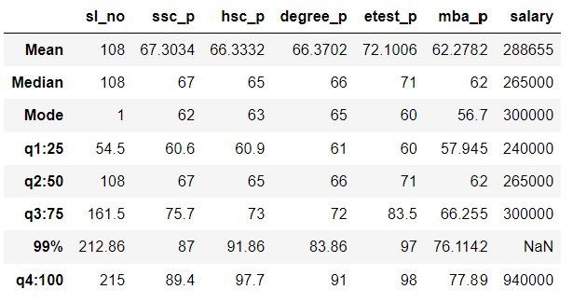

**Percentile Details of ssc_p :**

**q1:25** is **60.6**.This shows the Students Mark Performance of the first Quarter Year in SSLC Board Examination .That raises to **6.4 %** in the Middle of the Year , **q2:50** is **67.**Their Mark Performance Increases to **8.7%**  in the next Quartal part **q3:75** is **75.7**. They achieved **87 %** in 99th Percentile. Their mark increases 2% in the Last Percentile .**q4:100 is 89.4.**

**Percentile Details of hsc_p :**

**q1:25**  is **60.9**.This shows the Students Mark Performance of the first Quarter Year in Higher Secondary Examination. That raises to 4.1 % in the Middle of the Year , **q2:50** is **65.**Their Mark Performance Increases to **8%**  in the next Quartal part **q3:75** is **73**. Their Performance goes High Peak in the Final Quadrant .The Ratio Between q3 and **q4** is **24.7**. They achieved **91.86 %** in **99th** Percentile. Their mark increases **7.84%** in the Last Percentile .**q4:100 Value is 97.7**.

**Percentile Details of degree_p:**

**q1:25** is **61**.This shows the Students Mark Performance of the first Quarter Year in Under Graduate Degree Examination. That raises to **5** % in the Middle of the Year , **q2:50** is **66.**Their Mark Performance Increases to **6%**  in the next Quartal part **q3:75** is **72**. They Secures high percentage in their Final Part of the College. They achieved **83.86%** in **99th** Percentile. Their mark increases **7.14**% in the Last Percentile .**q4:100 is 91.**

**Percentile Details of etest_p:**

**q1:25** is **60**. This shows the Students Mark Performance of the first Quarter Year in Entrance Examination. That raises to **11** % in the Middle of the Year , **q2:50** is **71 .**Their Mark Performance Increases to **12.5%**  in the next Quartal part **q3:75** is **83.5**. They Performance increases **14.5%** in the Final Quadrant .They achieved **97 %** in 99th Percentile. Their mark increases **1%** in the Last Percentile .**q4:100** is **98.**

**Percentile Details of mba_p:**

**q1:25 is 57.945**.This shows the Students Mark Performance of the first Quarter Year in Post Graduate Degree Examination. That raises to **4.055** % in the Middle of the Year , **q2:50** is **62.**Their Mark Performance Increases to **4.255%**  in the next Quartal part **q3:75** is **66.255**.Their Final Segment mark variation is **11.635%** . They achieved **76.1142** % in 99th Percentile. Their mark increases **1.78%** in the Last Percentile .**q4:100 is 77.89.**

**Percentile Details of salary:**

The Salary Package of the Stuents from the Companies **25th** Percentile of Salary,**q1:25**  is **240000** .  **50th** Percentile of Salary **q2:50** is **265000.** **75th** Percentile of Salary **q3:75** is **300000** . **100th** Percentile of Salary **q4:100** is **940000**

This is the Detailed Report of the Overall Percentile of the Students in the Given Dataset.